ASSIGNMENT NO 4

TOPIC 1

Search engine optimization (SEO) :

Search engine optimization (SEO) consists in different operations which purpose is to increase the quantity and quality of traffic to a website through organic (non paid) search engine results.

The quality of traffic : The number of visitors to a website is not the most important thing in most cases. Visitors to a website must really be interested in the website they come to. Otherwise, they leave at once.

The quantity of traffic : Once you have quality traffic from search engine result pages (SERP), increasing the traffic should be your goal.

TOPIC 2

How does search engines work?

Search engines work by crawling hundreds of billions of pages using their own web crawlers. These web crawlers are commonly referred to as search engine bots or spiders. A search engine navigates the web by downloading web pages and following links on these pages to discover new pages that have been made available.

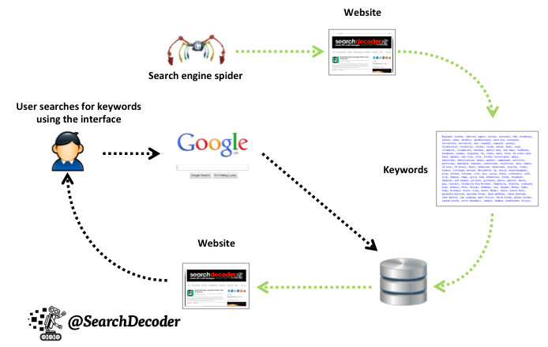

**TOPIC 3**

HTML5 structural semantic elements

Just as the web sites and URLs structures are important, the web pages structure also plays a role in SEO. A well coded page will make it a lot easier for the search engines to index contents. Search engines use standard HTML elements (tags) in trying to understand the content of a page. Optimizing the page structure directly improves the search engines understanding of a page. HTML5 adds new HTML elements to the existing ones called semantic elements that helps optimizing a page's structure. Semantic element are those carrying a sense, a meaning. Standard HTML elements are simply structural and basically carry no meanings.

